Positional Rearrangement

Definition
# Source: AI Source: Provided by: [Data Path: Persons Table -> ID Column: 1, Name_En Column: Motasem Essam] -> From: [ChatGPT] on [7/25/2026]
Positional Rearrangement is a type of geometric figure rearrangement in which figures or pieces are moved to new positions without changing their orientations, shapes, or sizes.
The pieces may be translated to different locations while keeping their corresponding sides parallel to their original directions.
Simple definition: Moving geometric figures to new positions without rotating or reflecting them.
Example: Moving one rectangle beside another to form a larger rectangle.

Main Classification
# Source: AI Source: Provided by: [Data Path: Persons Table -> ID Column: 1, Name_En Column: Motasem Essam] -> From: [ChatGPT] on [7/25/2026]
The following is a practical classification based on how the positions of figures change. These categories are descriptive and may overlap.

1. Horizontal Positional Rearrangement
# Source: AI Source: Provided by: [Data Path: Persons Table -> ID Column: 1, Name_En Column: Motasem Essam] -> From: [ChatGPT] on [7/25/2026]
Pieces move left or right without rotating or reflecting.
Example: Moving a rectangle to the right so that it touches another rectangle.
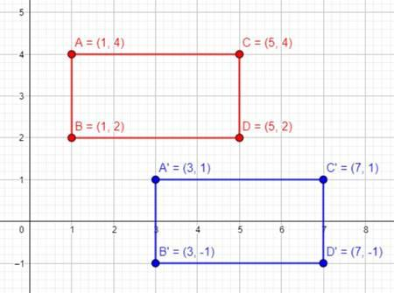

2. Vertical Positional Rearrangement
# Source: AI Source: Provided by: [Data Path: Persons Table -> ID Column: 1, Name_En Column: Motasem Essam] -> From: [ChatGPT] on [7/25/2026]
Pieces move upward or downward while maintaining their orientations.
Example: Moving a rectangle directly above another rectangle.
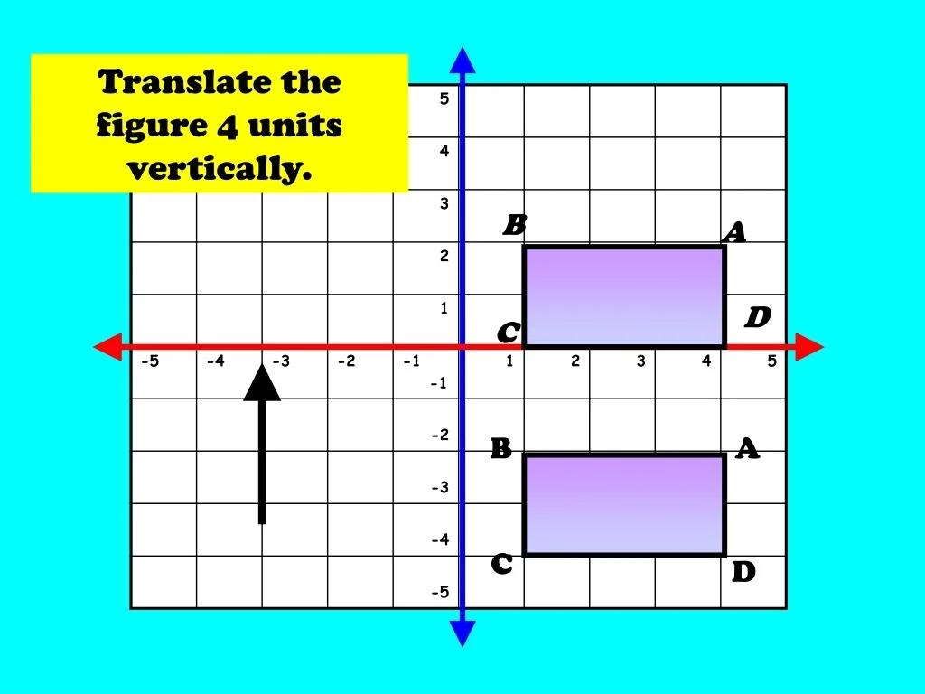

3. Diagonal Positional Rearrangement
# Source: AI Source: Provided by: [Data Path: Persons Table -> ID Column: 1, Name_En Column: Motasem Essam] -> From: [ChatGPT] on [7/25/2026]
Pieces move horizontally and vertically at the same time, along a diagonal direction.
Example: Moving a square three units right and two units upward.
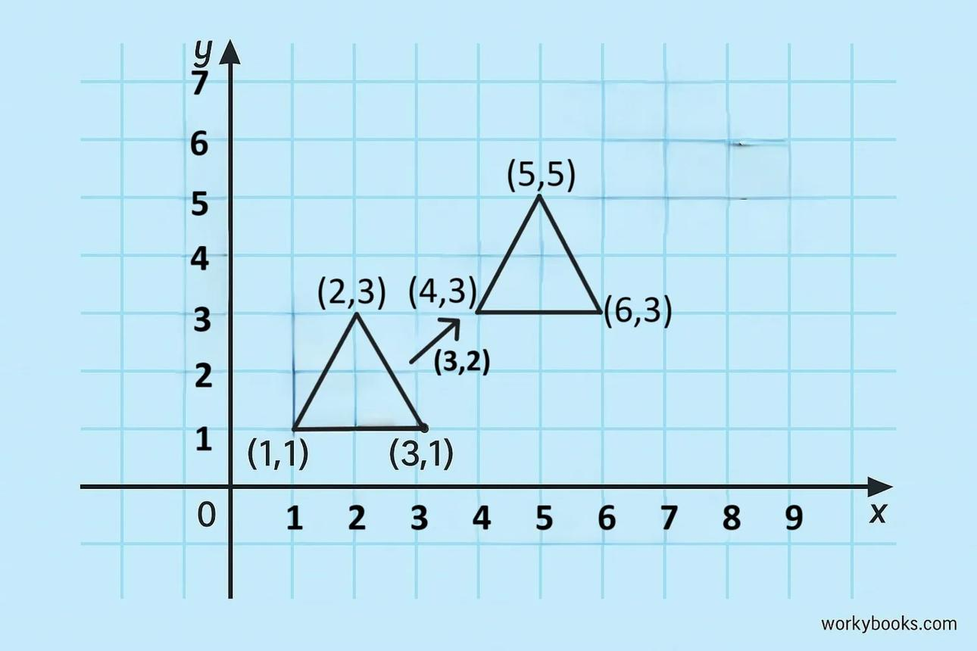

4. Adjacency-Based Positional Rearrangement
Pieces are moved into positions where their boundaries meet.
Example: Moving two rectangles together to form a larger rectangle.
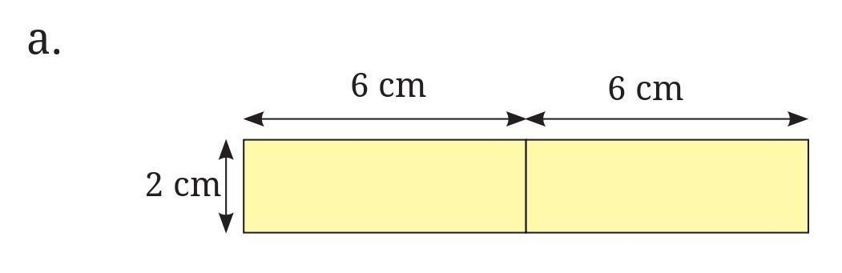

5. Grid-Based Positional Rearrangement
# Source: AI Source: Provided by: [Data Path: Persons Table -> ID Column: 1, Name_En Column: Motasem Essam] -> From: [ChatGPT] on [7/25/2026]
Pieces are translated into positions determined by a grid or regular spacing.
Example: Moving four identical squares into a $2×2$ arrangement.
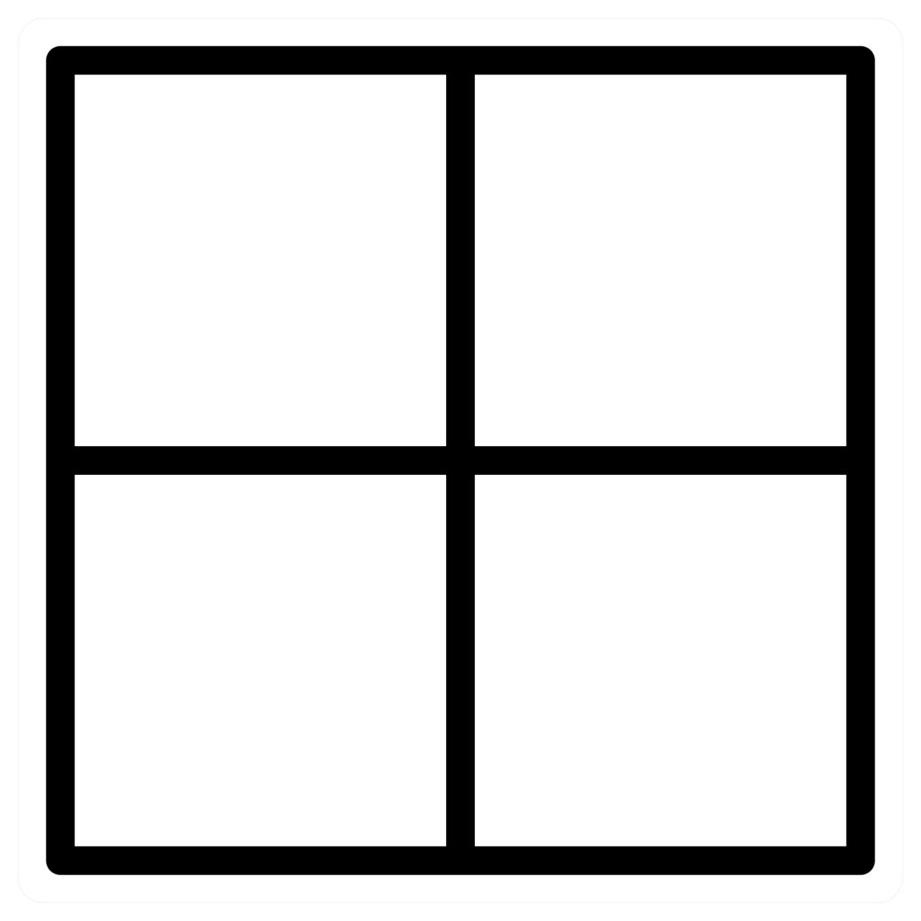

6. Separation-Based Positional Rearrangement
# Source: AI Source: Provided by: [Data Path: Persons Table -> ID Column: 1, Name_En Column: Motasem Essam] -> From: [ChatGPT] on [7/25/2026]
Pieces are moved apart while preserving their orientations.
Example: Separating two adjacent shapes to show their individual boundaries.
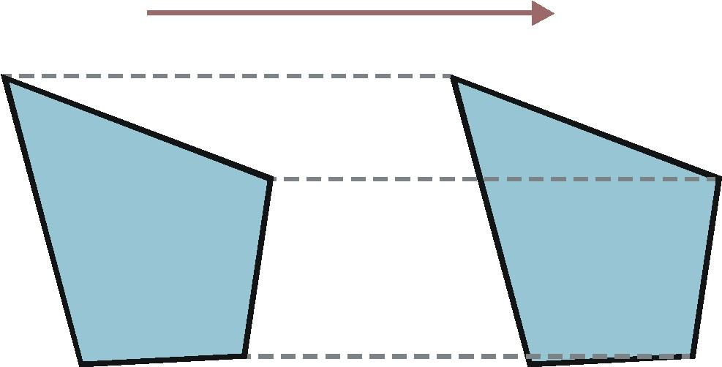

7. Sequential Positional Rearrangement
# Source: AI Source: Provided by: [Data Path: Persons Table -> ID Column: 1, Name_En Column: Motasem Essam] -> From: [ChatGPT] on [7/25/2026]
Pieces are moved one after another into a planned arrangement.
Example: Moving three rectangles successively to create a staircase-shaped configuration.
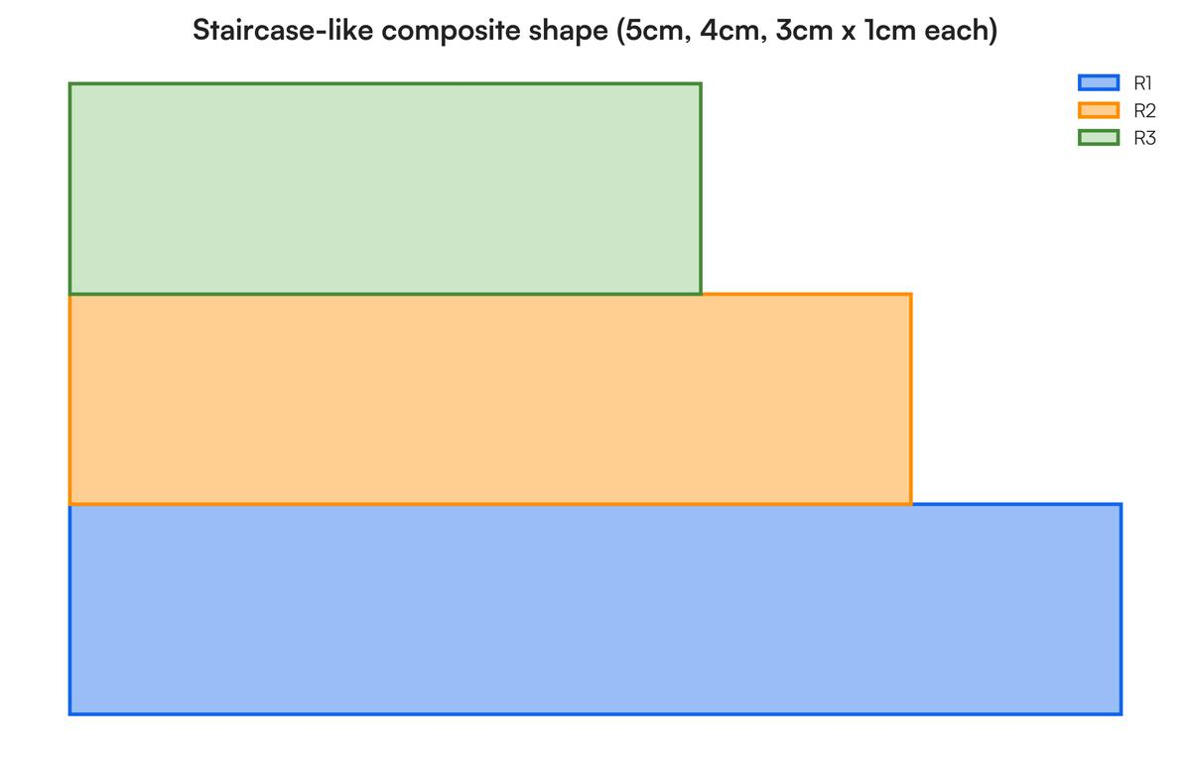

8. Pattern-Based Positional Rearrangement
# Source: AI Source: Provided by: [Data Path: Persons Table -> ID Column: 1, Name_En Column: Motasem Essam] -> From: [ChatGPT] on [7/25/2026]
Pieces are translated to create a repeated or organized pattern.
Example: Arranging identical tiles in rows to create a repeating geometric pattern.
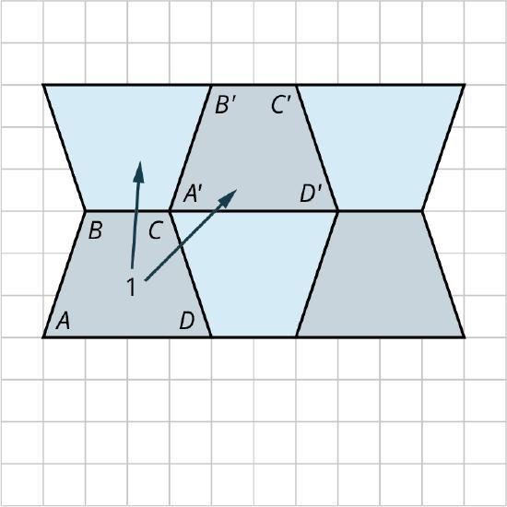

Detailed Mathematical Example
# Source: AI Source: Provided by: [Data Path: Persons Table -> ID Column: 1, Name_En Column: Motasem Essam] -> From: [ChatGPT] on [7/25/2026]
Consider two rectangles, each measuring $4×2$ units.
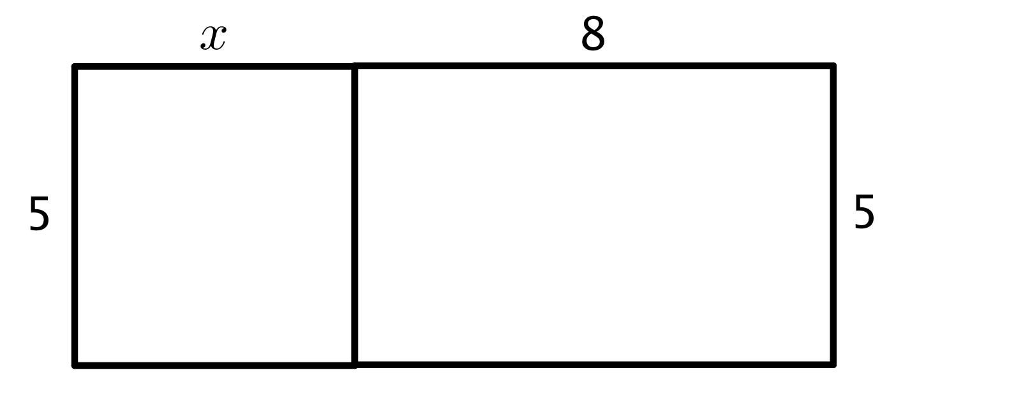
The first rectangle occupies
$$0≤x≤4, 0≤y≤2$$
Translate it $4$ units to the right. Each point follows the rule
$$\left(x,y\right)→\left(x+4,y\right)$$
The translated rectangle occupies
$$4≤x≤8, 0≤y≤2$$
The two rectangles form a larger rectangle measuring $8×2$.
- Area of each original rectangle: $4×2=8$.
- Combined area: $8+8=16$.
- Final rectangle area: $8×2=16$.
The pieces change positions, but their sizes, shapes, and orientations remain unchanged.

Key Properties
# Source: AI Source: Provided by: [Data Path: Persons Table -> ID Column: 1, Name_En Column: Motasem Essam] -> From: [ChatGPT] on [7/25/2026]
- Shape preservation: Each piece retains its original shape.
- Size preservation: All lengths and angles remain unchanged.
- Orientation preservation: Pieces are not rotated or reflected.
- Area preservation: Each piece retains its area.
- Arrangement change: Pieces may become adjacent, separated, or arranged in a pattern.
The general coordinate rule for translation is
$$\left(x,y\right)→\left(x+a,y+b\right)$$
where $a$ is the horizontal displacement and $b$ is the vertical displacement.

Classification Summary
# Source: AI Source: Provided by: [Data Path: Persons Table -> ID Column: 1, Name_En Column: Motasem Essam] -> From: [ChatGPT] on [7/25/2026]
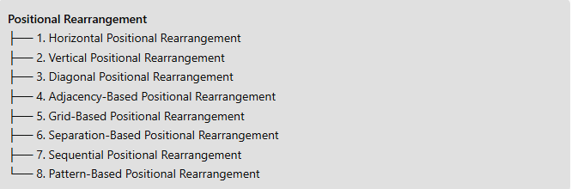
Positional Rearrangement
├── 1. Horizontal Positional Rearrangement
├── 2. Vertical Positional Rearrangement
├── 3. Diagonal Positional Rearrangement
├── 4. Adjacency-Based Positional Rearrangement
├── 5. Grid-Based Positional Rearrangement
├── 6. Separation-Based Positional Rearrangement
├── 7. Sequential Positional Rearrangement
└── 8. Pattern-Based Positional Rearrangement

Conclusion
# Source: AI Source: Provided by: [Data Path: Persons Table -> ID Column: 1, Name_En Column: Motasem Essam] -> From: [ChatGPT] on [7/25/2026]
Positional Rearrangement changes where geometric figures are located without changing their orientations, shapes, or sizes. Its fundamental mathematical transformation is translation, while the listed subtypes describe practical ways translated pieces can be organized.

